# A Definitive Guide to Generative AI with Amazon Bedrock

# Chapter 1: Introduction to Generative AI

Generative AI represents a revolutionary leap in artificial intelligence, empowering machines to create novel content and solutions across various domains. At its core, Generative AI involves algorithms that can generate data, designs, text, and even multimedia by learning from vast amounts of existing information. This groundbreaking technology is reshaping industries by enabling the automation of complex tasks and the generation of creative outputs that were once solely within the human domain.

The significance of Generative AI lies in its ability to tackle problems in innovative ways, making it a crucial tool in areas such as creative arts, scientific research, and business strategy. Its applications span from creating realistic virtual environments and personalized marketing content to accelerating drug discovery and optimizing supply chains. By harnessing the power of Generative AI, businesses and researchers can unlock unprecedented opportunities for growth and efficiency.

Looking ahead, Generative AI is having boundless potential. As the technology evolves, it promises to transform our approach to creativity, problem-solving, and decision-making. The future of Generative AI is not just about enhancing existing processes but also about pioneering entirely new paradigms of interaction and innovation.

In this chapter, you will explore the fundamentals of Generative AI, delve into its importance and applications, and envision its limitless future. Chapter will conclude with a summary that encapsulates the transformative impact of this technology and its role in shaping the digital landscape.

## Understanding Generative AI

As we stand on the cusp of a technological renaissance, Artificial Intelligence (AI) emerges as a cornerstone of innovation, promising to redefine the boundaries of possibility. This section introduces AI, outlining its profound impact on various domains and setting the stage for a deeper exploration of its mechanisms and applications. You will begin with an examination of the human vision schematic flow, providing context for how AI endeavors to replicate complex visual processing. Following this, you will delve into the schematic flow of computer vision, an AI subset designed to mimic human visual perception and interpretation through advanced algorithms.

The discussion then transitions to Generative AI, a groundbreaking technology that extends beyond traditional data analysis to create novel content. This segment unveils the underlying principles and architectures that drive Generative AI, focusing on Transformer based models, which have become pivotal in this field. The intricacies of Encoder Transformers and Positional Encoding are explored, detailing their roles in processing and generating data. You will also drive deep the internal workings of the Encoder and Decoder, shedding light on their contributions to the model’s functionality.

Despite their advancements, Transformer models are not without limitations. This section critically assesses the drawbacks of both the Transformer Encoder and Decoder, offering insights into their challenges and areas for improvement. Finally, a comprehensive taxonomy and classification of AI technologies provide a structured overview, helping to navigate the diverse landscape of AI innovations and their potential applications.

### **Exploring the Bright Future of Cutting-Edge Technology**

*Embrace interactive learning experiences, where practical engagement fuels comprehension, guided by tangible real-world instances.*

*By* ***Anonymous***

First you will explore couple of real life examples and followed by understanding Generative AI.

AnyCompany is an e-commerce platform which specializes in fashion, and lifestyle products that are sold online. It becomes evident from the numerous emails coming through customercare@anycompany.com. The challenge of increased numbers of incoming emails that have to be sorted out in order to give appropriate feedback is a crucial matter for AnyCompany. To improve the customer experience, streamline email management operational costs, and reduce customer waiting time before receiving a response or reply, AnyCompany seeks a highly scalable and resilient solution from the engineering team.

** AnyCompany is a fictitious company mentioned solely for purposes of this book. The following email content is also fictional and provided for illustrative purposes.



**Figure 1.1** - A sample email received by [customercare@anycompany.com](mailto:customercare@anycompany.com)

AnyCompany wants to use advanced technology that allows for automatic responses that are highly relevant and timely without any human intervention, thereby ensuring a better customer experience. Among others, one of the many uses of Generative AI demonstrates how this innovative technology has the potential to redefine the future of customer support services.

This journey is when you will have a clear understanding of intricate design considerations that must be learnt to successfully implement Generative AI solutions for such use cases. There will be nothing left unexplored from streamlining integration with existing systems to optimizing for precision and dependability.

But this is just an inception since as you go on this book, you will be introduced into various ranges of use-cases where Generative AI can assist in addressing issues associated with text-based interactions. This groundbreaking technology embodies depths which are both very profound and manifold.

To start your journey let’s look at an example email response generated by Anthropic's Claude 3 Haiku, a Large Language Model, on Amazon Bedrock. At the frontier of developing explainable, reliable and controllable AI systems that could change the field of future Artificial Intelligence, Anthropic an AI safety and research company. Though, you will learn more about Large Language Models and Amazon Bedrock in the subsequent chapter. But Large Language Models (LLMs) use neural networks to generate human-like text by analyzing extensive data, enabling various language tasks.

As you will explore Anthropic’s Claude 3 Haiku more closely in the subsequent chapter on Amazon Bedrock, you will obtain a full understanding of its fundamental principles, functionalities and applications as one-of-its-kind Generative AI model.



**Figure 1.2** - A email response generated by Claude 3 Haiku on Amazon Bedrock

Let you explore another real life example. FamousBurger, a fast-food chain that is well known all over the world, offers an extensive range of options including different types of hamburgers, French fries and various sodas from well-recognized suppliers. The Brand Manager has recognized the need for this company to focus on inventive combinations of these fast food favourites ahead of an upcoming specific campaign during a college festival.

In order to share these ideas with their team, the brand manager is now interested in making some quick creative visuals or pictures showing what they could do by mixing them up as part of their attractive campaign flier.

*\*\* FamousBurger is a fictitious company used for the purposes of this book.* The following images content is also fictional and provided for illustrative purposes.

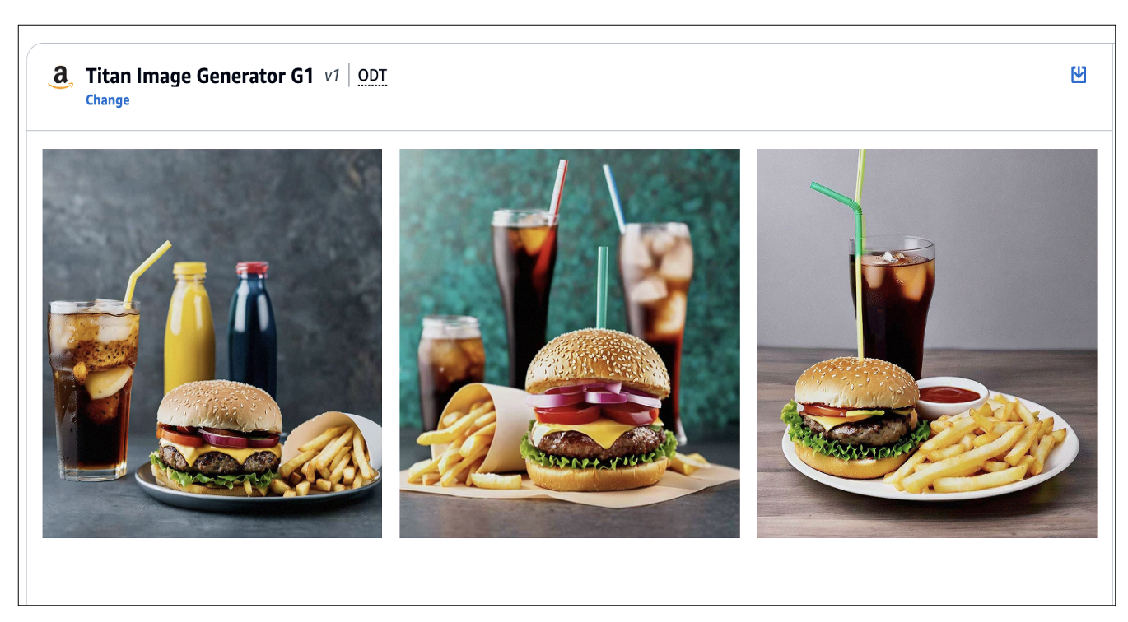

**Figure 1.3** – All the above images generated by Amazon Titan Image Generator G1 on Amazon Bedrock

This use case exemplifies how Generative AI can be applied in branding image generation and more. This is considered as a disruptive technology that will change the face of generative advertising overall.

This discussion will cover some intricate design considerations that should be made while implementing Generative AI solutions for similar use cases. This will include ensuring seamless integration with existing systems and optimizing for accuracy and reliability with a variety of design techniques and architecture patterns.

This isn't the end, but merely the start of something new and exciting! You shall be exploring a wide range of scenarios involving image-based interaction in which Generative AI can be used to address problems. You Get ready for some jaw-dropping stuff as you are going to learn how much further you can take this new technology.

The future belongs to advanced technology that is yet to be developed or even imagined. Generative AI techniques have undergone tremendous developments within a very short time. All this, which is fundamentally modelled on vast amounts of data, has shown how these Generative AI models can mimic human language production skills while other models generate pictures or even write music scripts and computer programs. Nowadays, traditional ways of interpreting Artificial Intelligence are quickly being replaced by this kind of revolutionizing technology.

Unlike conventional Machine Learning systems that usually handled narrowly defined problems, Generative AI systems are more versatile and thus enable new opportunities to come up. Such models may be finetuned according to the situation, finding their application in different spheres such as creative writing in journalism or content generation for the web industry, scientific investigations, and problem solving too.

Generative AI makes so amazing that it can enhance human intellect rather than just replacing it. These models are your intelligent assistants, and partners to make you more productive, creative, and insightful in what you do. For instance, a student or researcher could use a Generative AI model to synthesize and summarize large amounts of data quickly while they may focus on their main research activities without getting overwhelmed by the task. Writers might use large language models to produce initial drafts or bounce ideas off before subsequent polishing.

In contrast, there has been much more progress in Generative AI than in traditional symbolic AI approaches. Although the latter have contributed important insights into intelligence and problem solving, they were often constrained by having to rely on hand-engineered rules and difficulties scaling up to real-world problems.

Nevertheless, Generative AI, which is based on deep learning and driven mainly by data, has been shown to be progressive and flexible. As digital information explosion continues to grow together with computational capacity, these models are bound to become more powerful and sophisticated across wide range of fields like breakthroughs in scientific exploration, advancements in technological ingenuity, evolution of human-machine collaboration etc.

Indeed, the ascendance of Generative AI comes with string of ethical, societal and practical concerns that need careful negotiation. There would still be a lot of research needed to deal with questions around bias, safety as well as possible misuses. Nevertheless, it’s clear this revolutionary technology holds tremendous promise for future endeavors in the field. In fact, you can expect far more astonishing developments plus applications for Generative AI in next few years.

For example, OpenAI has made ground breaking progress in generative Artificial Intelligence since June 2018 when the first generative pre-trained transformer (GPT) was introduced by the researchers and engineers of OpenAI in a seminal paper. This specific version of expansive language generation model underwent initial pre-training on a large and diverse text corpus followed by discriminative fine-tuning for task-specific improvements. GPT models were built upon transformer-based, more detail in the next section, deep-learning neural network architectures, a shift from prevalent supervised learning approaches that demanded tons of human-labelled examples. This change enabled training of immensely large language models.

The first variant, GPT-1 had been an important breakthrough. However, the true revolution came in February 2019 with the release of GPT-2. It was a simple scaling up of its predecessor, with parameter count and dataset size both being multiplied by ten. GPT-2 contained 1.5 billion parameters that were trained on an eight million web pages-based dataset. (*Refer:* [*https://en.wikipedia.org/wiki/GPT-3*](https://en.wikipedia.org/wiki/GPT-3) )

Faster improvements in Generative AI have been responsible for increasingly sophisticated and adaptable language models that would develop in the future, changing our view of what Artificial Intelligence can do forever.

### **Introduction of Artificial Intelligence (AI)**

For one to grasp the idea behind Generative AI, it is necessary to go through a mesmerising vista of Artificial Intelligence (AI ). The dawn of AI has promised a remarkable effort to make machines think like human being in terms of learning, problem solving, decision making and perception.

The main focus of this is an attempt at creating systems that could mimic or even exceed the wonderful abilities of humans. Over the past few years there have been tremendous advancements in Artificial Intelligence on such things as computing power, data abundance and developments in algorithms and neural network architectures.

AI’s central objective is to create machines that can understand, interact with, and negotiate our complex world just as humans do. Without doubt, the application of AI in natural language processing and computer vision as well as speech recognition and knowledge representation has demonstrated its ability to surpass tasks that were previously seen as reserved for human brains alone.

Furthermore, Machine Learning has made AI to go beyond the traditional limits of rule-based programming. This change in concept allows computers to learn from data and recognize patterns without explicitly being programmed. Machine Learning algorithm’s adaptability and problem-solving abilities have never before been witnessed consequently giving way for ground breaking applications in multiple fields.

The AI landscape is a vast tapestry with many different segments woven into it, each focusing on different aspects of the field, as well as using various techniques appropriate for those areas of focus. These separate domains include supervised learning, unsupervised learning, reinforcement learning, deep learning and natural language processing which together form an increasingly sophisticated collection of AI systems that can address a wide range of problems.

Still, the frontiers of AI continue to march forward, carrying along that potential which may transform lives and societies or even businesses themselves. Technologies such as self-driving cars or intelligent personal digital assistants are bound to shape the world we live in. In addition, medical diagnostics will be carried out by machines while financial analysis will also draw heavily from Artificial Intelligence.

To unlock the true potential of Generative AI and its captivating capabilities, it is important to embrace a thorough understanding of the fundamental principles and advancements within the broader realms of Artificial Intelligence. In the next sections, we will explore more into this amazing field by elaborating on its key concepts as well as uses while doing that; we will build up from these foundations.

Let’s delve into the diagram of human vision and compare it to the diagram of artificial computer vision. By studying these processes, we can try to understand how each system sees and thinks about visual information with Artificial Intelligence ( AI) being specifically Deep Learning. Though, the purpose of this book is not drive deep on Artificial Intelligence ( AI). But, you will get an overview of AI from the below figure.

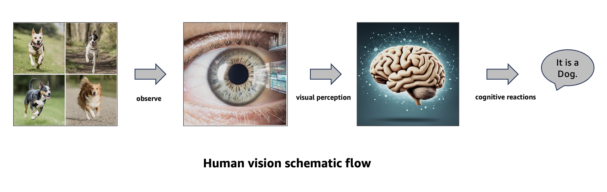

**Figure 1.4** – Human vision schematic flow

** All the above images generated by Amazon Titan Image Generator G1 on Amazon Bedrock.

### **Human Vision Schematic Flow**

1. A Picture is watched by human eye.

2. Visual perception is produced by human brain.

3. Cognitive reactions are created by Human Brain and identification of “Dog”.

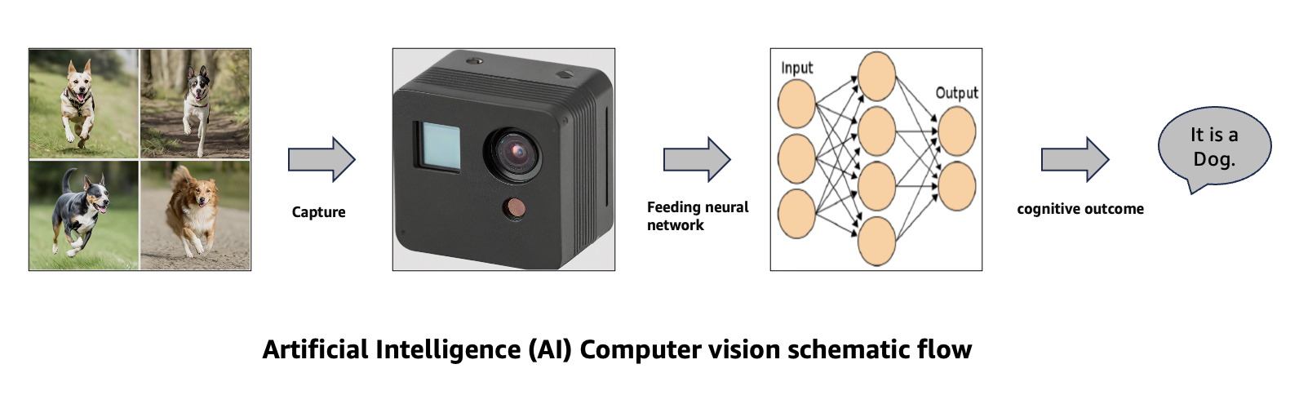

**Figure 1.5** – Artificial Intelligence Computer vision schematic flow

** All the above images generated by Amazon Titan Image Generator G1 on Amazon Bedrock.

### **Artificial Intelligence Computer vision schematic flow**

1. Camera captures the picture as a sensory device like camera.

2. Data has been fed into deep neural network.

3. The deep neural network gives cognitive outcome of “Dog”.

### **Introduction of Generative AI**

Having travelled so far in the field of Artificial Intelligence (AI), let’s have a look at the amazing world of Generative AI. This is an amazing aspect of AI which marks a sudden move from attempts to make computers capable of processing and analysing information only, into making them create.

AI generation has been revolutionized by computers, opening up new creative possibilities beyond the traditional constraints of data manipulation and pattern recognition. Unlike traditional Machine Learning and Artificial Intelligence, which is best at tasks like classification, prediction, and decision-making, Generative AI systems are designed to produce unique texts, images, sounds, or even intricate datasets.

The fundamental concept of Generative AI involves a profound shift in how you think about intelligent systems. These machines aren't limited to just responding to or modifying data. They can also produce dynamic contents by combining new concepts that are relevant to their current environments. This transformative power can be applied to a wide range of tasks, such as simulating complex scenarios, personalizing content, and crafting inventive stories and visually captivating images.

Bottom of Form

Deep learning architectures such as Autoencoders, Generative Adversarial Networks (GANs), Convolutional Neural Networks (CNNs), Recurrent Neural Networks (RNNs), Variational Autoencoders (VAEs), Attention Mechanisms, and Transformer-based models have made remarkable strides in the field of generative Artificial Intelligence. These networks produce works that resemble those made by humans because they use neural networks to learn patterns and distributions within datasets.

Generative AI applications cover areas ranging from content creation through data augmentation into image-to-image translation as well as language modelling. That said, these capabilities have a potential of changing industries like media and entertainment, education, scientific research among others and enabling individuals and corporations to tap into the energy of AI driven creativity and innovation.  
  
Nevertheless, there comes great responsibility with great power. In addition to exploring deeper into Generative AI space, you must also consider ethical implications as well as possible problems associated with producing highly realistic but probably misleading contents. Thus addressing issues of bias, privacy and societal ramifications will be paramount for ensuring that Generative AI is developed responsibly and beneficially.

Below are the fundamental principles, architectures, and applications of Generative AI that you will explore more deeply to help you in understanding this fascinating frontier of AI. Get ready as you take a journey that will open up the endless possibilities of machines for creation, innovation and pushing of limits beyond what is possible.

### **Underlying Principles and Architectures**

Going deeper into the captivating realm of Generative AI, it is important to understand the underlying principles and architectures that drive this transformative field. These are the basic building blocks which are used to develop different features of Generative AI systems.

At the heart of Generative AI lies a profound revolution in how machines perceive and interact with data. While conventional AI models excel at tasks like classification and prediction, Generative AI systems engineer original contents themselves. This generative approach is based on these models’ ability to learn patterns in data as well as its respective distributions hence allowing them to produce meaningful content.

One of the most ground-breaking prototypical architectures that have driven forward the development of Generative AI is Generative Adversarial Network (GAN). GANs are motivated by adversarial training where they pit two neural networks against each other – a generator and a discriminator. While the generator is supposed to produce plausible-looking outputs, the discriminator aims at distinguishing between the generated content and authentic data samples. In this way, GANs learn to generate very convincing diverse contents capable of fooling even the keenest human eye. ( *Refer* [*https://arxiv.org/abs/1406.2661*](https://arxiv.org/abs/1406.2661))

Another well-known architecture in Generative AI today is Variational autoencoders (VAEs). VAEs use statistical methods for modelling data with latent representations capturing underlying structures and patterns. This allows VAEs to study from the compressed representation that describes input data such as pictures or voice clips. As such, they can generate new samples in a close resemblance of the original distribution leading to numerous possibilities for generating contents or augmenting datasets. ( *Refer* [*https://arxiv.org/abs/1606.05908*](https://arxiv.org/abs/1606.05908))

Another well-known architecture in Generative AI today is Transformer Based Models Encoders, Decoders. We will drive deep in below section. This is very important to understand for you.

### **Transformer-Based Models**

In the last couple of years, models with transformers have become a game changer in natural language processing (NLP) and beyond. They have taken NLP to new heights by not only being able to handle sequential data but also being applied in areas such as computer vision, speech recognition and reinforcement learning. This architectural paradigm stands out from traditional recurrent or convolutional neural networks since it depends on self-attention mechanisms to capture relationships and dependencies within input sequences.

This comprehensive guide will delve into elementary parts of models based on transformers, including encoders and decoders, as well as certain extensions and modifications that have made them even better. From their inception through becoming popular across cutting edge research and industry applications, transformers have redefined the landscape of deep learning by showing unmatched performance levels across different tasks.

This discussion traces the evolvement of the transformer architecture by considering its origins, key architectural elements, and seminal contributions that have made it a globally acclaimed concept in contemporary Machine Learning.

This overview should provide an understanding of the principles underlying transformer-based models as well as their real-life use cases to allow you to get a better grasp on this innovative technology that would define future AI driven solutions. From theory to practice, this is what one expects when walking through transformers path which promises more efficient, versatile and contextually informed approach to ML systems.

The transformer architecture is a key turning point in the history of natural language processing (NLP) and deep learning, a 2017 Google paper Known as “**Attention Is All You Need**”, this research radically changed the conventional NLP models by proposing an alternative route based solely on self-attention mechanism. ( *Refer* [*https://arxiv.org/abs/1706.03762*](https://arxiv.org/abs/1706.03762))

At the time when transformers were not introduced, NLP applications mainly depended on the recurrent neural networks (RNNs) or the convolutional neural networks (CNNs) for processing word sequences. However, these types of architectures failed to efficiently capture long dependencies and had computational inefficiency during training.

Innovative potential of transformer architecture was centered around overcoming these limitations. Through self-attention mechanisms, words could be dynamically weighted within sentences; therefore, it encoded input into fixed-size vector representations with improved contextual understanding.

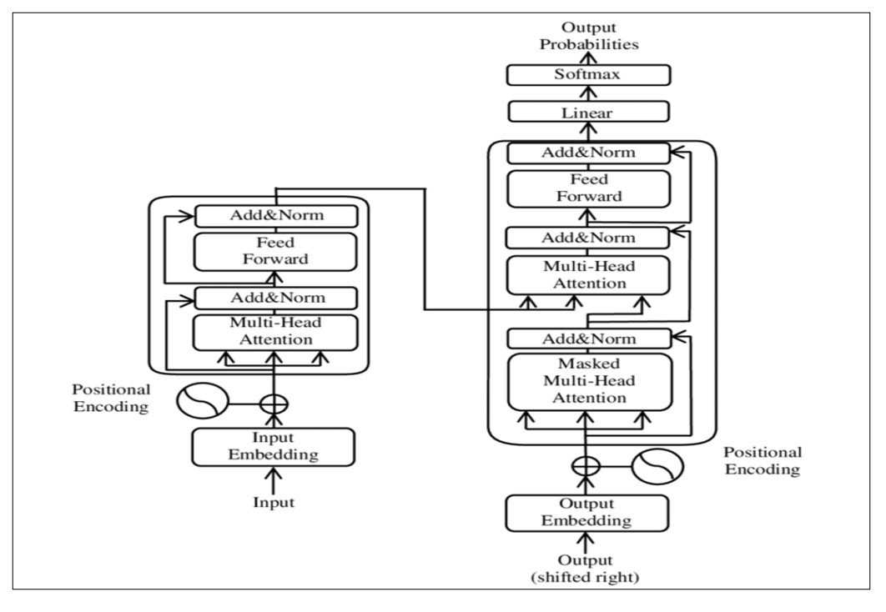

**Figure 1.6** – Refer https://en.wikipedia.org/wiki/Transformer_(deep_learning_architecture)

First you understand the Transformer model in layman words without the advanced mathematics. If you are interested to drive deep, recommendation is the original research paper. ( *Refer* [*https://arxiv.org/abs/1706.03762*](https://arxiv.org/abs/1706.03762)) You will learn Transformer model on the context of language perspective.

Another, special type Deep Learning model is Recurrent Neural Network (RNN). This model has been trained to convert a sequential data inputs into a sequential data outputs based on request to the model ( *Refer:* [*https://aws.amazon.com/what-is/recurrent-neural-network/*](https://aws.amazon.com/what-is/recurrent-neural-network/) ). On the other hand, Long Short Term Memory (LSTM) is type of Recurrent Neural Network (RNN) which is having higher memory power to retain the long term dependencies and context in the data compare to the Recurrent Neural Network (RNN) ( *Refer:* [*https://arxiv.org/abs/1909.09586*](https://arxiv.org/abs/1909.09586)).

RNN and LSTM is a recursive model has a limitation to understand long term dependencies. Both the models are more computationally expensive when dealing with complex data with scale. The Google paper was developed a new architecture design patterns called Transformer to get over the limitation of RNN, LSTM and similar kind of sequential network based model. Transformer architecture become most advanced model for latest generation NLP based applications.

RNN and LSTM model takes the input of text one at a time in token format while the complete sequence of tokens is transmitted simultaneously ( parallel processing of data) through the transformers sections of those architecture. Whereas, The Transformers model eliminates the recursion process. It follows Self-attention mechanisms which is unique resilient and scalable kind of attention mechanism. Refer Chapter 4 to understand the concept of token.

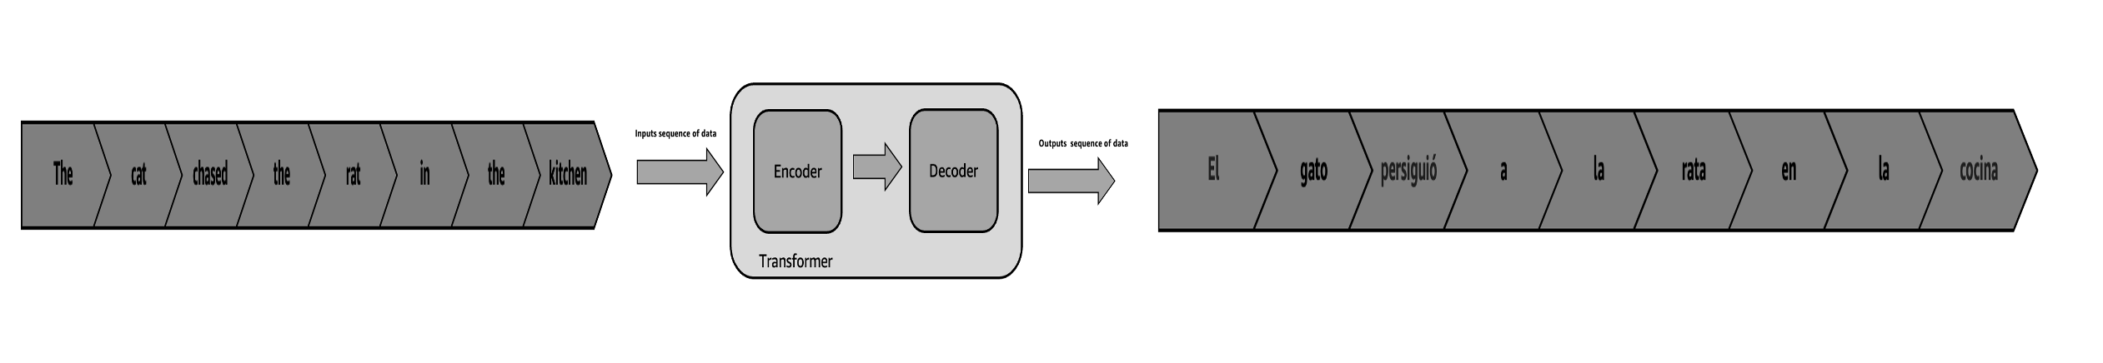

**Figure 1.7** – Schematic diagram of Transformer Architecture

You will understand the entire architecture in the purview of a phrase sentence from English to Spanish as mentioned in the Figure 1.7. The example of English phrase as an input sequence is "**The cat chased the rat in the kitchen.**" The example of Spanish phrase as an output sequence is " **El gato persiguió a la rata en la cocina.**" corresponding to the input sequence. Transformer has two parts of the architecture Encoder and Decoder respectively. The encoder takes the input sequence and learn the representations of the given English sentence and feeds the representation to the Decoder. The decoder takes the Encoder’s representation as input and generates the Spanish sentence as output of sequence.

### **Encoder Transformer**

The Encoder is a just a Neural Network. It is the key component of the Transformer architecture. It is in charge of processing the input sequence and producing a meaningful representation. The purpose of the encoder is to provide context information to the input so that the model can comprehend the relationships and dependencies between the different elements in the sequence. Transformer consists of a stack of Encoders. The out of one Encoder is the input of the next Encoder. The final Encoder return the representation which is the input for the Decoder as mentioned in the Figure 1.8. The original paper “**Attention Is All You Need**” talks about 6 Encoders in the Encoder stack one on top of the other. But you will see two Encoders in this explanation for better understanding of this architecture.

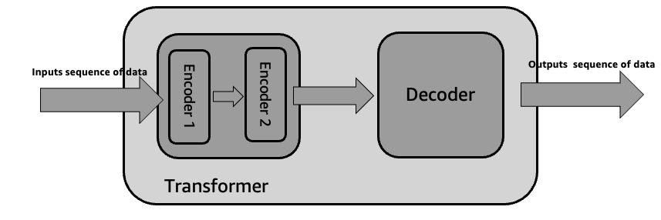

**Figure 1.8** – Encoder Stack

### Each Encoder has two components Multi head attention followed by Feedforward network as mentioned in the Figure 1.9. Before understanding Multi head attention and Feedforward network, you should first explore Positional Encoding and Self-Attention Mechanism.

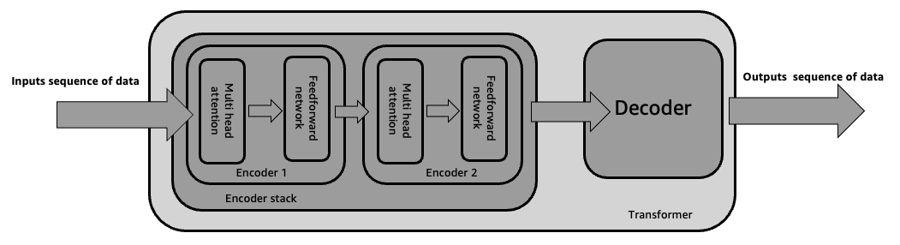

**Figure 1.9** – Inside Encoder Stack

### **Positional Encoding**

Any mathematical model can’t understand the text. So, you often tokenize an input sequence into distinct elements, numerical equivalent, called as tokens. For example, the English phrase as an input sequence is "**The cat chased the rat in the kitchen.**" which is a fixed length sequence of 8. These tokens are typically numerical indices in a vocabulary dataset. So, it may be sequence of number like ( 100, 500, 700, 100, 350, 1000, 50, 100, 950). All the number here are only representation purpose for your better understanding. The number 100 corresponds to “**the**”. All the number depends on the vocabulary datasets as mentioned before. Refer Chapter 4 to understand the concept of token.

First, you need to convert each token into an embedding vector. This is common process before feeding the input sequence into neural network. During training, the transformer picks up those embeddings from scratch. You will learn embedding more in the Chapter 6.

One of the preprocesses before Transformer Encoding is to convert input embeddings into positional encoding as shown in the Figure 1.10. Position of a text is very important in context of that sentence, neighborhood words and pre and post sentences. For example, the position of the word “**dog**” and “**rat**” are very important in the overall context of the sentence. The meaning of "**The cat chased the rat in the kitchen.**" and "**The rat chased the cat in the kitchen.**" are not the same.

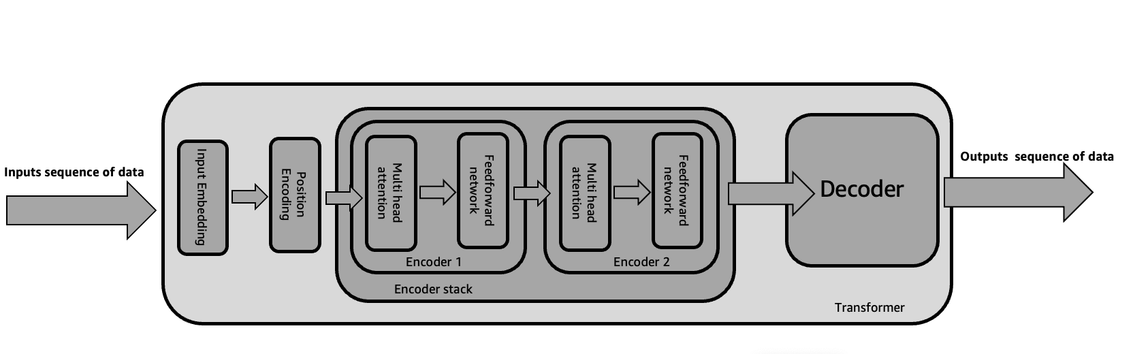

**Figure 1.10** – Positional Encoding

### Self-Attention Mechanism

Before going deep into the Encoder architecture, you should have idea about Self-Attention Mechanism. For example, one sentence “**That man knew his friend was right, but he didn't write it down.**”

The meaning of “**right**” is not same as “**write**”. So, the context matter to form a sentence.

Self-Attention is a special type of mechanism that allows the model selectively focus on relevant information. Model provides maximum weightage. For example, the word “**he**” can refer to “**That man**” or “**That man’s friend**”. But model will give maximum weightage that “he” refers to “**That man**” based on the context of the entire sentence. There is mathematical way you can drive deep of this topic. (*Refer:* [*https://arxiv.org/pdf/2104.09079.pdf*](https://arxiv.org/pdf/2104.09079.pdf)).

Let's delve deeply into each component of the Transformer encoder.

### **A. Multi-Head Attention mechanism**

Each Encoder is made up of two key layers Multi-Head Attention mechanism and Feed-Forward Neural Network. Each Encoder uses the self-Attention mechanism to enrich each token within input embedding vector with contextual information from the whole sentence. Each token may have more than one relationship with other token of the embedding vector. Hence, the self-attention mechanism starts multiple heads parallel processing (Figure 1.11). This is completely different than sequence-to-sequence processing in the RNN and LSTM model. This Multi-Head Attention mechanism has an ability to represent each token at various parts of the input embedding vector. Language modelling, language translation, and text summarization requires to capture relevant contextual information and long-term dependencies for better outcome from the model. Multi-Head Attention mechanism helps to achieve this. There is a mathematical aspect to understand how Multi-Head Attention mechanism works. ( *Refer* [*https://arxiv.org/abs/2310.12680*](https://arxiv.org/abs/2310.12680)*)*

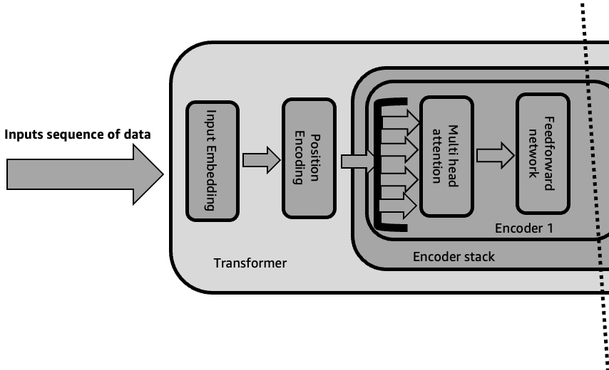

**Figure 1.11** – Multi-Head Attention

### **B. Feed-Forward Neural Network**

The Feed-Forward Neural Network is the final layer in each Encoder. It is applied individually to each input token. The representations produced by the Multi-Head Attention mechanism are further refined by this sub-layer. So, each token on the embedding vector, with contextual information from the multi-head attention, goes through the position-wise feed-forward layer for further transformation ( Figure 1.12). Both the sub layers uses, an element-wise addition, residual connections. Residual connections carry previous embeddings to the subsequent layers to enrich the embedding vectors with additional information obtained from the Multi-Head Attention mechanism calculations and position wise feed-forward. Then, each Encoder goes for layer normalization to significantly improve the training and performance of Encoder.

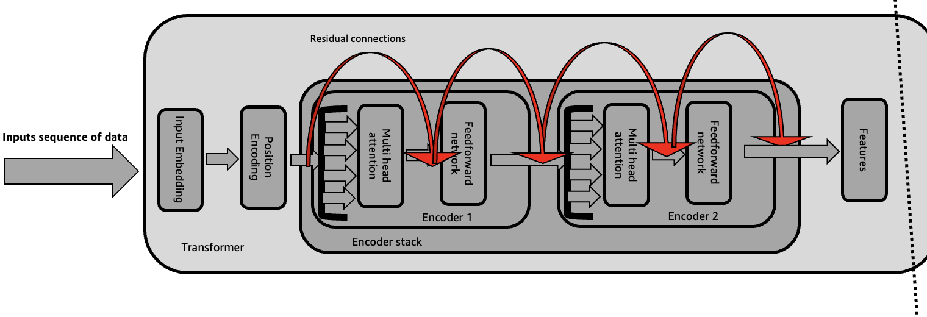

**Figure 1.12** – Feed-Forward Neural Network with residual connections

### **Decoder Transformer**

You understand that Encoder stack, multiple Encoders, extracts feature from an input sequence in the previous section. Whereas, The Decoder uses the features to generate an output sentence. For example, The Encoder extracts features from the input "**The cat chased the rat in the kitchen.**". Whereas, the Decoder generates the output sequence "**El gato persiguió a la rata en la cocina.**" based on the ask language translation English to Spanish. The output of the last encoder, part of Encoder stack, becomes the input features to the decoder (Figure 1.13). Transformer consists of a stack of Decoder. The output of one Decoder is the input of the next Decoder. The final Decoder return the final output sequence, usually one token at a time. Each decoder layer is made up of three sub-layers: Masked Multi-Head Attention, Multi-Head Attention and Feed-Forward Neural Network. You can rotate this below figure (Figure 1.13) vertically. Then, the whole picture will look like the diagram from the original paper.

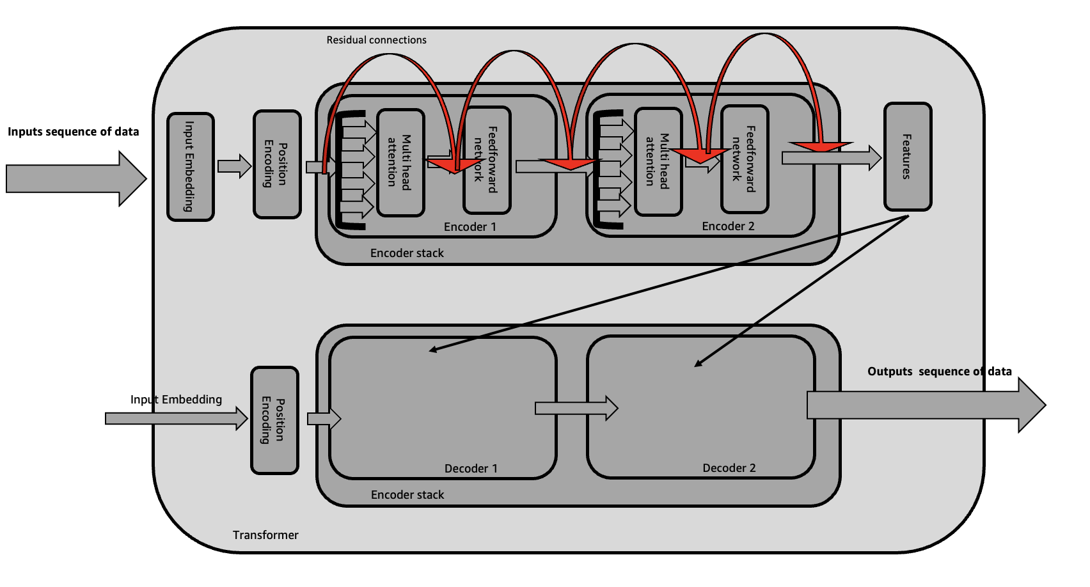

**Figure 1.13** – Decoder Stack

Let's delve deeply into each component of the Transformer decoder.

### **A. The Masked Multi-Head Attention**

One of the important layer within each Decoder is Masked Multi-Head Attention mechanism. It enables the model to concentrate on previous token generation in order to anticipate the subsequent token.

This mechanism makes sure that Decoder will only see list of previous token, not that which is yet to come. This mechanism will gradually increase the visibility of input sentences by the masks ( Figure 1.14). The below table information will give your idea about Masked Multi-Head Attention mechanism.

|  |  |
| --- | --- |
| [ 1, 0 , 0 , 0, 0, 0, 0, 0, 0 ] | “El” |
| [ 1, 1 , 0 , 0, 0, 0, 0, 0, 0 ] | “El gato” |
| [ 1, 1 , 1 , 0, 0, 0, 0, 0, 0 ] | “El gato persiguió” |
| [ 1, 1 , 1 , 1, 0, 0, 0, 0, 0 ] | “El gato persiguió a” |
| [ 1, 1 , 1 , 1, 1, 0, 0, 0, 0 ] | “El gato persiguió a la” |
| [ 1, 1 , 1 , 1, 1, 1, 0, 0, 0 ] | “El gato persiguió a la rata” |
| [ 1, 1 , 1 , 1, 1, 1, 1, 0, 0 ] | “El gato persiguió a la rata en” |
| [ 1, 1 , 1 , 1, 1, 1, 1, 1, 0 ] | “El gato persiguió a la rata en la” |
| [ 1, 1 , 1 , 1, 1, 1, 1, 1, 1 ] | “El gato persiguió a la rata en la cocina” |

**Table 1.1** – demonstration of output from Masked Multi-Head Attention mechanism

** For all English speaker the meaning of "**El gato persiguió a la rata en la cocina**" is

"**The cat chased the rat in the kitchen**"

### **B. The Multi-Head Attention**

The Decoder has a Multi-Head Attention mechanism. It allows to attend to the encoder’s output ( features) and context of the input sequence. This mechanism performs similarly as that in Encoder Multi-Head Attention mechanism. But, Decoder Multi-Head Attention mechanism extract the input from the outputs of the encoder( Figure 1.14).

### **C. The Feed-Forward Neural Network**

The Feed-Forward Neural Network is the last sub-layer in each Decoder. It is applied individually to each output token. The representations produced by the attention mechanisms are further refined by this sub-layer. This mechanism performs similarly as that in Encoder Feed-Forward Neural Network. But, Decoder Feed-Forward Neural Network extracts the input from the outputs of the Decoder Multi-Head Attention mechanism( Figure 1.14).

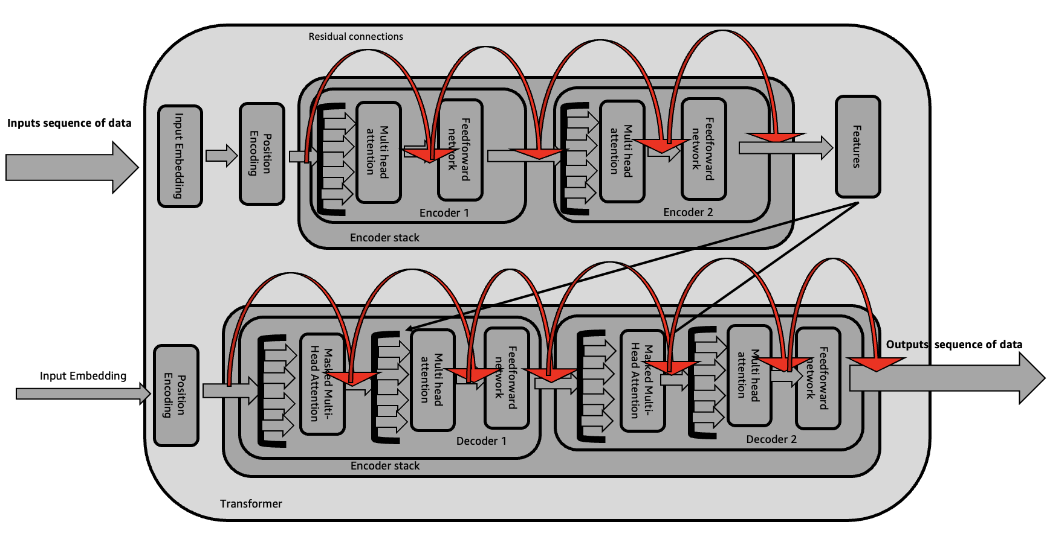

**Figure 1.14** – Inside Decoder

Let's delve deeply into Variation of the Transformer Architecture.

### **Variation of the Transformer Architecture**

So far, you have covered a high-level overview of the main components of transformer architecture.

Let's delve deeply into how the prediction process works end to end with a simple example.

Imagine a translation task, which was the original purpose of the transformer architecture. You will use a transformer model to translate an English phrase into French. First, the input words are tokenized using the same tokenizer that trained the network. These tokens are fed into the encoder, passing through the embedding layer and the multi-headed attention layers. The output of these layers goes through a feed-forward network to produce the encoder's output, which is a deep representation of the input sequence's structure and meaning (Figure 1.14).

This representation is then passed to the decoder to influence its self-attention mechanisms. A start-of-sequence token is added to the decoder's input, triggering it to predict the next token based on the encoder's contextual understanding. The decoder's output goes through a feed-forward network and a final softmax layer to generate the first token. This loop continues, with the output token feeding back into the input to generate subsequent tokens, until an end-of-sequence token is produced. The final sequence of tokens can then be detokenized into words, completing the translation (Figure 1.6).

The complete transformer architecture includes both an encoder and a decoder. The encoder processes input sequences into deep representations, while the decoder generates new tokens from these representations in a loop until a stop condition is met. In translation, both components are used, but they can also be separated for different tasks.

Encoder-only models, like BERT, are used for tasks where the input and output sequences are the same length, such as classification. Encoder-decoder models, like BART and Amazon Titan, are effective for tasks like translation, where the input and output sequences can differ in length. Decoder-only models, like the GPT family, BLOOM, Jurassic, and LLaMA, are versatile and can generalize to various tasks.

The main goal here is to provide enough background to understand the differences between these models and to read their documentation.

Understanding the Transformer architecture reveals that not all generative AI models necessarily use both encoder and decoder components. Each architecture has unique strengths suited to specific natural language processing tasks. Encoder-only models excel at comprehending and representing input text, making them ideal for tasks like classification and entity recognition. Decoder-only models focus on generating coherent text, which is useful for applications such as text completion and language generation. The encoder-decoder architecture integrates the advantages of both, enabling tasks like machine translation and summarization. Let’s explore detailed use cases and examples for encoder-only, decoder-only, and encoder-decoder models.

**Encoder-Only**

Encoder-only models, also known as Autoencoding models, are pre-trained using a technique called masked language modeling. In this method, certain tokens in the input sequence are randomly masked, and the model's task is to predict these masked tokens to reconstruct the original sentence. This approach is also referred to as a denoising objective. Autoencoding models develop bi-directional representations of the input sequence, meaning they understand the full context of a token, considering both the preceding and following words. These models are particularly well-suited for tasks that benefit from such bi-directional context. They can be used for sentence-level tasks, like sentiment analysis, or token-level tasks, such as named entity recognition or word classification.

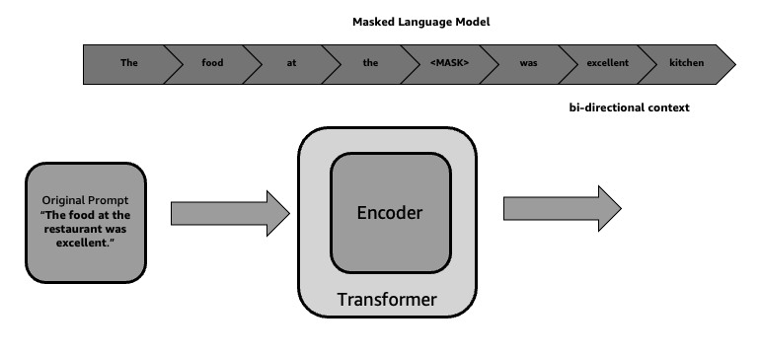

**Figure 1.15** – Encoder Only

|  |  |  |
| --- | --- | --- |
| Use cases | Description | Example |
| **Text Classification** | Categorizing text into predefined labels, such as spam detection or sentiment analysis. | Classifying customer feedbacks as positive, negative, or neutral. |
| **Named Entity Recognition** | Identifying and classifying entities in text, such as names, dates, and locations. | Extracting company names, dates, and locations from news articles. |
| **Question Answering** | Providing precise answers to questions based on given context. | Answering questions about a passage of text, such as identifying the main idea or key details from news articles. |
| **Semantic Similarity** | Measuring the similarity between two pieces of text. | Identifying duplicate questions on a forum or matching job descriptions to candidate profiles. |
| **Language Understanding** | Improving the comprehension of text in tasks like summarization or paraphrasing. | Generating concise summaries of long documents or rephrasing sentences while preserving their meaning. |

**Table 1.2** – Encoder-Only

These use cases demonstrate the versatility of encoder-only models in enhancing natural language processing capabilities across various applications.

**Decoder-Only**

Decoder-only models, also known as Autoregressive models, are pre-trained using a technique called causal language modeling. In this approach, the training goal is to predict the next token based on the preceding sequence of tokens, a task known to researchers as full language modeling. These models mask the input sequence, allowing them to see only the tokens that precede the token being predicted, without any knowledge of the sentence's end. The model processes the input sequence token by token to predict the next one, resulting in a unidirectional context as opposed to the bidirectional context of encoder models. By learning from numerous examples, the model develops a statistical understanding of language. Decoder-only models utilize just the decoder component of the original architecture, without the encoder, making them suitable for text generation. Larger decoder-only models also exhibit strong zero-shot inference capabilities and can perform a variety of tasks effectively.

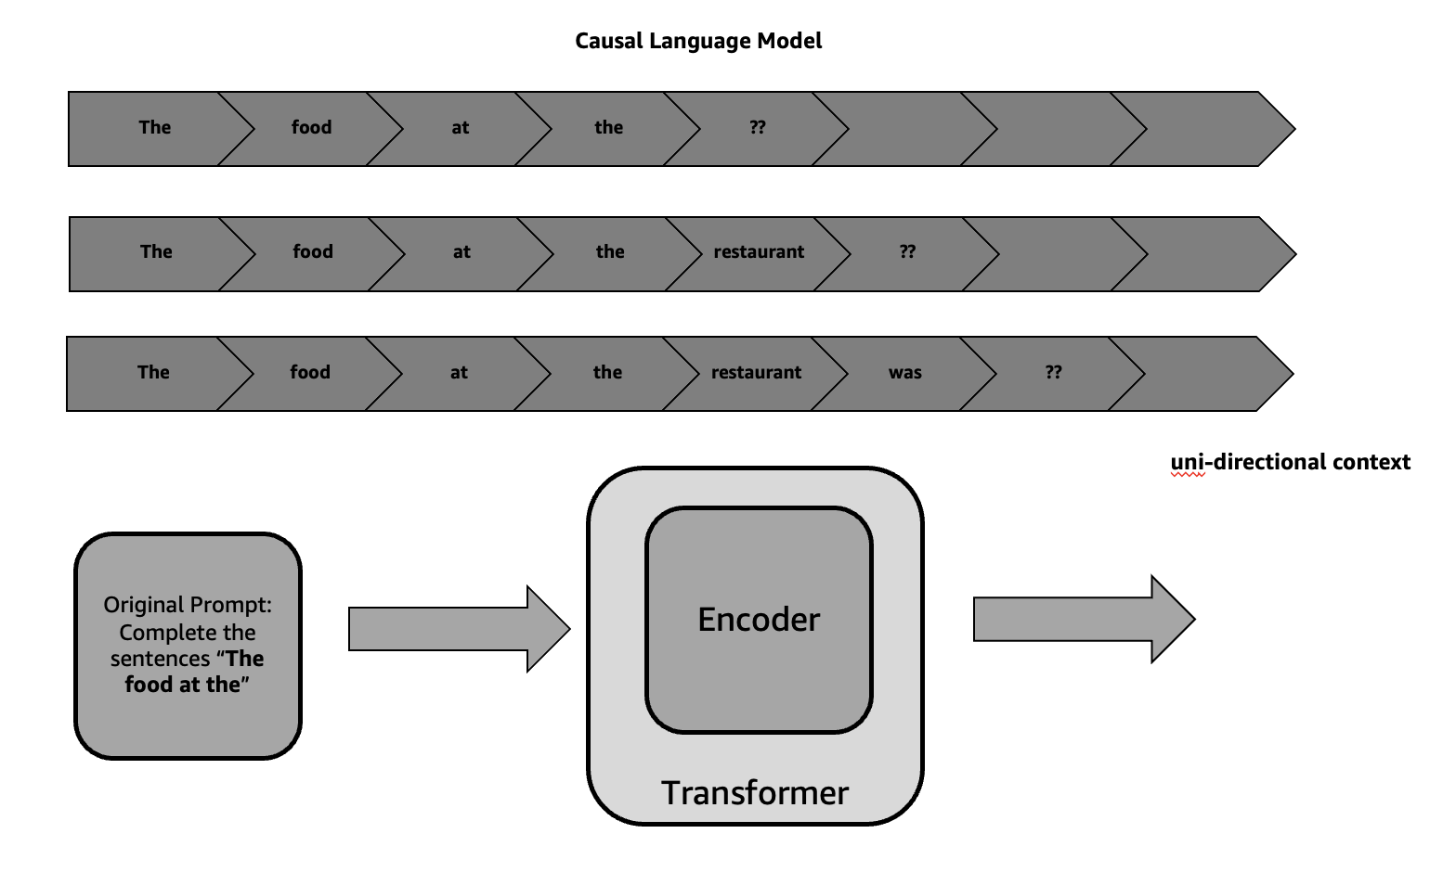

**Figure 1.16** – Decoder Only

|  |  |  |
| --- | --- | --- |
| Use cases | Description | Example |
| Text Generation | Creating articles, stories, or essays from a brief prompt | Generating a news article headline based on a topic. |
| Conversational AI | Powering chatbots and virtual assistants that respond to user queries and engage in dialogue, like GPT-3 used in various customer service applications. | Creating a virtual chatbot for customer providing support for their insurance. |
| Creative Writing | Assisting in writing fiction, poetry, or song lyrics by expanding on a provided theme or initial text. | Generating a fictional story for a little magazine. |
| Code Generation | Producing code snippets or even entire programs from natural language descriptions. | Filling in missing parts of a text, such as completing a partially written email or essay. |
| Content Completion | These models leverage their extensive training on diverse datasets to generate high-quality, contextually relevant content. | Generating product description from product name and image of the product. |

Table 1.3 – Decoder-Only

These use cases demonstrate the versatility of decoder-only models in enhancing natural language processing capabilities across various applications.

**Encoder-Decoder-Only**

The sequence-to-sequence transformer model, Encoder-Decoder-Only, is the final variation of the transformer architecture, utilizing both the encoder and decoder components. Pre-training objectives for these models can differ. Model pre-trains its encoder through span corruption, where random sequences of input tokens are masked and replaced with a unique Sentinel token. Sentinel tokens are special additions to the vocabulary that do not correspond to any actual words in the input text. The decoder's job is to reconstruct these masked sequences in an auto-regressive manner, producing outputs that begin with the Sentinel token followed by the predicted tokens. Sequence-to-sequence models are versatile and can be used for tasks such as translation, summarization, and question-answering, making them particularly useful when both the input and output are text.

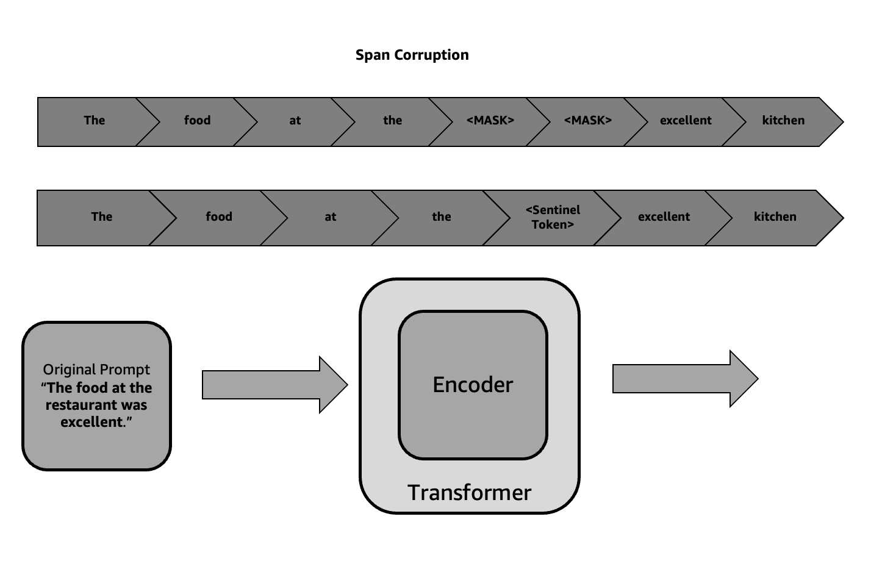

**Figure 1.17** – Encoder-Decoder Only

|  |  |  |
| --- | --- | --- |
| Use cases | Description | Example |
| **Machine Translation** | These models are employed to translate text from one language to another. | For instance, Google's Transformer model can translate sentences between languages with high accuracy. |
| **Text Summarization** | Encoder-decoder models can generate concise summaries of long documents. | BERTSUM, for example, is used to produce summaries by understanding and compressing the input text. |
| **Question Answering** | In this use case, the model generates answers based on a given context or passage. | Models like T5 (Text-To-Text Transfer Transformer) can be fine-tuned for specific question-answering tasks. |
| **Image Captioning** | Encoder-decoder models can describe images by generating textual descriptions based on the visual input. | The image is processed by an encoder (often a convolutional neural network), and the description is generated by the decoder. |
| **Speech Recognition and Synthesis** | These models can transcribe spoken language into text and vice versa. | In speech-to-text systems, the encoder processes audio features, and the decoder generates the corresponding text. |

Let's delve deeply into some of the potential drawbacks of Transformer Encoder and Transformer Decoder.

### **The Transformer Encoder's Drawbacks**

Although the Transformer architecture has been widely adopted and successful up to this point, there are still some notable limitations that should be taken into account.

**Complexity in computing**

* The transformers encoder employs attention as the mechanism of choice. This has a computational complexity of n^2 where n represents the length of the input sequence.
* This is an expensive and memory-consuming quadratic complexity especially when dealing with longer input sequences.

**Limited Capacity to capture long-range dependencies**

* In spite of its attention mechanism, the standard transformer encoder still be limited in capturing long-term dependencies within the input sequence especially for complex jobs requiring detailed understanding about long range relationships.

**Sensitivity to change in Order of inputs and Adaptability**

* Without explicitly modeling the order of inputs, the Transformer Encoder works on the principle that they are, simply put, independent tokens. For some tasks this can lead to problems if model becomes sensitive to word-order dependence.

### **The Transformer Decoder's Drawbacks**

**Autoregressive in nature**

* In an autoregressive manner the Transformer decoder generates the output sequence were based on already generated ones each token of data is produced.
* Such a sequential approach can make this whole process much slower than non-autoregressive models, thus limiting parallelism.

**Bias in Exposure**

* During training, the Decoder is exposed to the ground truth output sequence, but during inference, it must rely on its own previously generated tokens.
* Exposure bias may be caused by this discrepancy between training and testing in which the model performs worse as it encounters errors or deviates from the training data.

**Lack of explicit modelling of structured output**

* The Transformer Decoder generates the output sequence as a flat, linear sequence of tokens without explicitly modelling any structured output like syntax trees or logical forms.
* There could be less relevance for tasks requiring more structured or hierarchical outputs.

To resolve these challenges, researchers have had to design other forms of the transformer such as Transformer-XL, Reformer, non-autoregressive Transformer models that can allow for this and improve their performance.

By incorporating ideas from a wider range of Machine Learning techniques, such as likelihood-based modelling, adversarial training, and variational inference, generative AI systems outperform conventional frameworks.

In this later part of the chapter and subsequent chapters, while you will explore a wide range of applications and practical implications of Generative AI, it is essential to understand these basic principles and architectures. By mastering these foundations, you will be able to keep up with the most recent advancements in this fascinating field as well as make use of them for transformational purposes.

### **A Comprehensive Taxonomy and Classification**

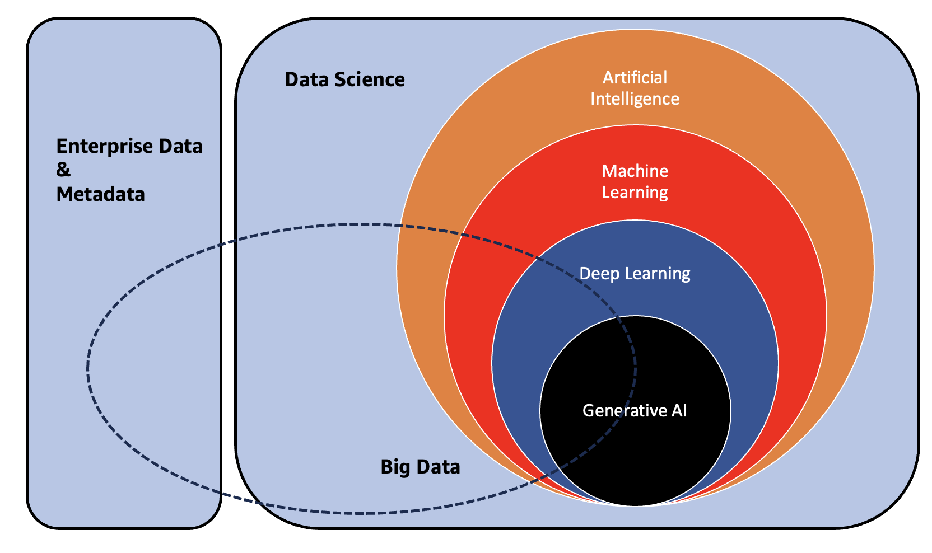

**Figure 1.7** – Image inspired from <https://www.cmu.edu/intelligentbusiness/expertise/genai-principles.pdf>

The relationship that exists between Data and AI is symbiotic in nature as AI cannot be valuable without data. Even, comprehending data without AI can also prove to be problematic. Artificial Intelligence (AI) including Machine Learning (ML) is heavily reliant on big data for its effectiveness. In addition, this relation plays a critical role in assisting businesses to get business context and helps for data driven decision. An intuitive data foundation consists of mature data governances, data metadata management, and data platform (data warehouses, Data Lake, Data Lake House setup) is very important align with the organization goals to achievement better AI-ML use case.

Let us discuss some of the important points in between some areas of taxonomy.

**Data Science and Big Data**

* Data science is a field which involves applying statistics methodology, Machine Learning algorithm, and variety of data visualization techniques to curate insights and knowledge from the historical structured and unstructured data.
* Whereas, Big Data refers to manage, governance, process, organize structured and unstructured information with the latest methodology compare to traditional database tools which cannot handle efficiently.
* Data science relies on big data to derive more meaningful insights through the application of advance analytics techniques which capable of handling the volume, velocity and variety of big data.

**Data Science and Artificial Intelligence**

* Artificial Intelligence and Data Science are two closely related fields that often overlap in their objectives and methodologies though Data Science is having bigger landscape like statistical analytics and other mathematical analytics.
* Data science involves analysing data to extract patterns, trends, and insights, while AI focuses on building intelligent systems that can think like humans.
* In AI applications, it is important to have Machine Learning techniques such as natural language processing, computer vision etc. It helps the system learn from data, make decisions based on data and carry out tasks by itself like humans.

**Big Data and Machine Learning**

* Machine learning algorithms always trains effectively with the massive amounts of data.
* Machine learning algorithms can train and identify patterns analysing huge amounts of information so that model than provide better prediction.
* Even, Machine learning model needs more variety of data to evaluate better and more mature based on context on the business.
* So, Big data have very crucial role to manage, governance, process, organize the data to support Machine learning lifecycle. Machine learning pre-process jobs processed and analyses massive amount of data using big data platforms like Hadoop and Spark.

**Big Data and Deep Learning**

* Deep learning which is a branch of Machine Learning involves artificial neural networks that are made up of many layers capable of understanding the data.
* The availability of large labeled data for training purposes on complex patterns and relationships makes big data crucial in deep learning models.
* This makes deep learning techniques well-suited to handling big data in areas such as computer vision, image analysis, NLP, and speech recognition among various others.

**Big Data and Generative AI**

* Generative AI that generate new content like images, text or music which imitates human creativity needs domain adaption.
* Diverse and abundant datasets facilitate Generative AI systems’ exploitation by big data for reasons of model training.

## 1.2 Importance and Applications

Here are some key points highlighting the importance of Generative AI in the industry:

**Enhancing Creative Potential:** The Foundation Model entails producing new and unique content, such as texts, audios, videos, and images, to provide creative professionals with new ideas and inspiration.

**Automating Content Creation:** Generative Artificial Intelligence (GAI) can automate the content creation process so that human beings can concentrate on more strategic matters. This shift promises enhanced efficiency and effectiveness across a spectrum of industries, including education, marketing, advertising, and entertainment.

**Personalization and Customization:** As a result, Foundation Models can be specially trained on certain datasets to produce content that suits unique preferences, enhancing the personalization of user experiences.

**Overcoming Limitations:** Traditional content creation limitations such as lack of language proficiency, unavailability of relevant knowledge or skills, or time-consuming nature associated with enhancing quality outputs are resolved by Generative AI.

**Advancing Scientific Research:** Lastly, hypothesis generation, modeling complex systems and accelerating discovery processes are all examples where Generative AI can be used in scientific research.

**Fostering Enhanced Learning Experience:** Generative AI ensures more education and training by creating personalized learning materials, interactive educational experiences, and virtual tutors.

**Empowering Everyone:** Demystifying Generative AI models to generate content in various languages, formats, styles enable masses to access information and experiences.

**Ethical AI Governance:** Essential elements of AI for generating purposes are bias addressing, transparency promoting, privacy concern, responsible use practices demonstration that shows a positive impact on society – the ethical relationship with the world which is supposed to benefit community at large.

**Fostering Technological Advances:** Progressing developments as well as enhancements related to Generative AI can make major strides in technology within different areas such as natural language processing, computer vision and beyond.

## 1.3 The Infinite Potential of Generative AI & Future

There are countless possibilities that arise by combining technologies such as Artificial Intelligence and Generative AI which is the heart of this revolution. This powerful technology has infinite potential to tackle various customer-related issues, streamline current use cases with more complexity and clarity.

To look at how much Generative AI can influence our future, we should go on this intriguing trip.

In terms of technology interaction, content creation and problem solving Generative AI will change everything for us. Rather, this disruptive tech-boutique is a game changer that will disrupt industries, create new pathways for innovation as well individual and corporate empowerment.

Generating hyper realistic visual experiences blending reality with unreality in ways previously unimaginable. Composing an original piece of music or constructing engaging stories, it’s all within reach thanks to Generative AI’s creative expertise. Generative AI systems demonstrate a versatile skill set beyond the domains of content making so that they operate across different modalities (from texts to images) and through audio-visual capabilities becoming multi-modal experiences.

The real power of Generative AI comes from its ability to personalize solutions at scale to suit the distinct needs and tastes of clients and customers. Through deep learning and natural language processing, Generative AI can produce customized experiences, products, or services that strike a chord with each individual ushering in new eras in industries and our relationship with technology.

Generative AI will continue making inroads across various industries as it matures, going beyond traditional boundaries. Whether it is in healthcare, finance, manufacturing or entertainment this technology will address complex problems as well as stimulate innovation and make existing business cases operate more efficiently than ever before.

It is an infinite voyage where Generative AI should not only empower humans but open up new avenues for cooperation and co-creation. With this transformative technology come we are standing on the threshold of future wherein the demarcation between human beings and machines wane resulting into an era characterized by unparalleled progressiveness, innovation as well as troubleshooting.

|  |  |
| --- | --- |
| **Potential Areas of future innovation** | **Real-Time Example** |
| Unlocking Unprecedented Realism and Creativity | Recent years have seen Generative AI powered deepfake technology make significant strides. Deepfake videos incorporate realistic faces into existing videos that are fake. The ethical issues raised pose by this technology signify the potential of Generative AI to create hyper-realistic content. |
| Exploring the Multimodal Capabilities | Amazon Titan Multimodal Embeddings G1 model, a neural network capable of generating images from textual descriptions, showcases multimodal capabilities. Users can describe complex scenes or concepts, and Amazon Titan Multimodal Embeddings model generates corresponding images, pushing the boundaries of AI creativity. |
| Mass-Scale Customer Personalization through AI Innovation | OTT platform (streaming platform) utilizes Generative AI algorithms to personalize content recommendations for millions of users. By analysing viewing habits and preferences, OTT platform suggests tailored content, enhancing user experience and engagement. |
| Industry-Specific Diverse Solutions/Applications | In the healthcare sector, Generative AI helps in analysis of medical imaging. Systems can identify abnormalities in medical scans thus supporting radiologists in their diagnosis and treatment plans. |
| Augmented Human-Machine Collaboration for Enhanced Productivity | Engineers collaborate with Artificial Intelligence algorithms through CAD/CAM generative design software to optimize designs. Engineers define constraints and goals while working alongside AI to explore a wide range of design possibilities resulting in innovative solutions. |
| Harnessing AI for Content Integrity and Verification | For content moderation, social media platforms have designed Generative AI. Thus, harmful or inappropriate materials are automatically spotted and deleted, guaranteeing safety of the users online. |
| Conversational Virtual Interfaces | Generative AI is what makes voice assistants such as Amazon’s Alexa possible, with their natural language processing capabilities. In this way, these interfaces make sense of user commands and queries in a conversational manner enhancing user experience. |
| Innovating Artistry and Design Evolutions | Digital art creation has been revolutionized by Generative AI. Therefore artists produce unique surreal pieces that challenge traditional art forms. |
| AI-Powered Music and Entertainment Evolution | An example of this is an AI music composition platform that can create personalized royalty free music for various uses. Users can select genre, mood and length while Generative AI algorithms compose original records according to their requirements. |
| Pioneering the Path of continuous Learning and Self-Enhancement | Amazon Code Whisperer simplifies Machine Learning code generation on Amazon SageMaker platform notebook for developers who lack advanced knowledge. Its increase the rate of AI development. |
| Nurturing Responsible AI Development | Amazon’s Development of Responsible AI is key in ensuring justice, openness and responsibility in AI systems. For this reason, it has incorporated ethical concerns into the development of AI to reduce any possible prejudices and dangers that may arise. |
| Pioneering Environmental Consciousness | Generative AI is used in energy optimization systems to minimize environmental impacts. The intelligent electricity distribution networks based on Artificial Intelligence algorithms are adjusted dynamically according to demand for optimizing efficiency and minimizing waste. |
| Navigating Legal and Regulatory Landscapes | Governments worldwide are adopting regulations that govern the use of AI technologies. The General Data Protection Regulation (GDPR) of the European Union has provisions that cover decision-making by AI as well as privacy protection regulations that support responsible Al deployment. |
| AI in Advancing Scientific Discovery | DeepMind’s AlphaFold, an Artificial Intelligence-based protein folding system, brings about a transformation in biological research. This makes it possible for AlphaFold-2 to predict protein structures accurately speeding up drug discovery and providing new directions for healthcare and biotechnology industries. |
| Personalized AI Companions | Virtual personal assistants such as Alexa offer individualized help. These AI-powered systems understand a user’s preferences and behaviour, offering tailored recommendations and aid on many tasks. |
| Revolutionizing Learning Experiences | Adaptive learning platform use Generative AI to personalize language learning experiences. These platforms analyse users’ performance and change the content of lessons along with their difficulty levels in order to maximize learning outcomes. |
| AI-Generated Innovation | Generative AI platform allows for innovative thinking across industries through tools for data analysis, natural language processing, Machine Learning among others. Businesses take advantage of the features enabled by the platform to develop mind-boggling solutions which then put them ahead of others in competition. |

In conclusion, the future of Generative AI is teeming with endless possibilities where humanity can express its desires, dreams and visions about a better tomorrow. Through harnessing responsibly and ethically the unfathomable power of Generative AI, you have an opportunity to co-create a future without limits for creativity or boundaries against innovation.

Let us deep dive into some of Mckinsey’s conducted research details. ( Refer: <https://www.mckinsey.com/capabilities/mckinsey-digital/our-insights/the-economic-potential-of-generative-ai-the-next-productivity-frontier#introduction> *)*

**Generative AI’s Impact on Productivity**

* Potential of adding between $2.6 trillion and $4.4 trillion to the global economy per year.
* Almost 1.5 times the entire GDP of UK in 2021.
* Can increase overall AI impacts by 15-40%.

**Areas of Greatest Value**

* Customer Operations, Marketing & Sales, Software Engineering, R&D.
* 75% of the possible value across 63 uses cases they analyzed.

**Specific Industry Impact**

* Largest gains could be seen in banking, high tech and life sciences.
* Banking sector could generate additional value up to US$340bn.
* Retail and consumer goods’ potential impact is estimated at about $400bn-$660bn

**The Changing Nature of Work**

* Generative AI can automate approximately 60-70% current employee activities
* It speeds up technical automation that could raise productivity growth between 0.1-0.6% annually
* Could grow total productivity by between 0.5 to 3.4 percentage points

**Challenges and the Path Forward**

* Manage risks while ensuring ethical alignment
* Support workers during transition and re-skilling
* Re-imagine primary business processes for harnessing full potentials of Generative AI

Generative AI is just starting, and it needs proactive strategic actions from the business and societal leaders in unlocking its enormous possibilities.

## 1.4 Summary

The chapter introduces the concept of Generative AI using AnyCompany, a fictional e-commerce company that is looking to automate its customer email responses with advanced technology. It explains how Generative AI could revolutionize customer service and other applications by generating highly relevant and personalized content, as demonstrated by models such as Anthropic’s Claude 3 Haiku.

After that, the chapter provides an overview of Artificial Intelligence (AI), from modern machine learning approaches to traditional rule-based programming. In addition, it is evident that recent progress in deep learning architectures such as Transformer-Based Models with Encoder-Decoder have led to strong Generative AI models capable of generating language, pictures and even music in a way that looks similar to human-like creativity. It also emphasizes how Generative AI has the capability to make people better at their jobs and solve problems in other areas like marketing, scientific research amongst others.

Finally, chapter four dissects principles and architectures behind Generative AI; one could argue for it being focused on Transformer-Based models with their Encoder-Decoder structures. Additionally, some of the limitations of these models are mentioned including computational complexity and input order sensitivity but it is worth noting that much effort has been made by scholars to overcome such drawbacks. This chapter also acts as a prelude for further discussion on Generative AI along with its transformative implications in forthcoming chapters.